Celebrate Arbor Day
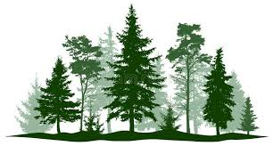

Plant A Tree

ARBOR DAY CELEBRATION
ST. CLAIRSVILLE – TREE CITY USA, 21-Year Designation
When: May 21, 2021 at 11:00 A. M.
Where: Central Park (below Rec Center), 102 Fair Avenue
Invocation: Father Thomas A. Chillog, St. Mary’s Church
Welcome: Mayor Kathryn Thalman
Special Guest Speaker: Lola Lewis, Regional Urban Forester, with the Ohio Department of Natural Resources’ Division of Forestry Region 6
Presentation of 2019 and 2020 TREE CITY USA Designation: Ms. Lewis
Invited guests include: Recreation Board, St. Clairsville Ruritan Club, Belmont County Tourism, St. Clairsville Public Library, St. Clairsville Area Chamber of Commerce, St. Clairsville-Richland City Schools and St. Mary’s Church

