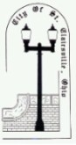
Office of the Director of Public Service/Safety
Jeremy Greenwood
P.O. Box 537-100 North Market Street, St. Clairsville, OH 43950
Office: 740.695.0156 Fax: 740.695.4069
Email: jgreenwood@stclairsville.com

Dear Customer:
The City of St. Clairsville Water Department is now required to locate, to the extent that there are any, lead service lines in the city’s water distribution system. US and EPA regulations now in effect will require this information and associated mapping, along with new requirements for sampling and monitoring for lead in drinking water.
While the City is responsible for the portion from the water main to your property line, the homeowner is responsible for the pipe that runs from the property line to the building. Because the City’s records are not up to date, as customers may have changed service lines or made repairs, the City is asking each customer to complete a short survey to report the material of their service line.
It would require extensive time, as well as inconveniences to our customers if our employees were to enter each home or building to determine what material the service line is made of. If you require assistance with the location or testing, please contact a plumber or handyman to assist, currently the City is unable to have employees complete this task.
The survey is on the back of this notice. It can be completed and mailed back to the city building, 100 N. Market St. St. Clairsville OH, 43950, or mail back with the next utility bill. There is also an option to drop the survey off in the utility drop box in the alley behind the Municipal building. The scratch instructions are as follows (if the pipe is covered or wrapped, expose a small area):
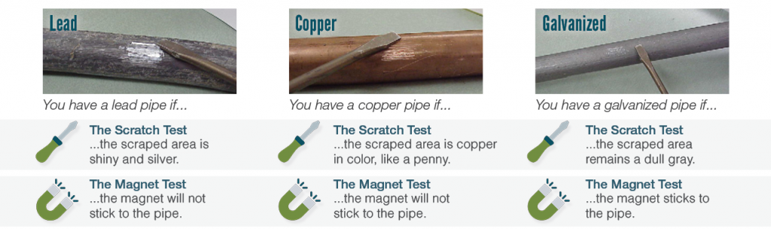
There will be a postcard mailed later, as a reminder to complete the survey. If you would like more information regarding the testing and how to accomplish this task, please visit our website: www.stclairsville.com or call (740)-695-0156 or (740)-695-1324 for more information.
The City of St. Clairsville thanks you for your cooperation.

Jeremy Greenwood,
Director of Service/Safety
JG:em
PLEASE PRINT/FILL OUT LEGIBLY--- RETURN IN MAIL, INCLUDE WITH RETURN UTILITY BILL, OR DROP OFF IN UTILITY DROP BOX.
City of St. Clairsville Municipal Building
100 N Market St.
St. Clairsville, OH 43950
(740)695-0156 or (740)695-1324

_____________________________
Service Number (located on utility bill)

________________________________
Customer Name (First/Last)

_____________________________________________
Property Service Address

____________________________
Year Property Built

Type of Service
☐ Single Family ☐ Business/Commercial ☐ Multi-Family ☐ Other ___________________

Direction of Water Service Line
From what direction does the water service line come into your property? (Example: Service line comes into the basement on the NW corner of the house)

Water Service Line Point of Entry
☐ Garage ☐ Crawl Space/Utility Room
☐ Basement ☐ Other ____________________

Records of Work
If any records of work performed on the service line, especially if the line has been replaced, please indicate the work performed and the date.

Service Line Material
(See Scratch Test Instructions- use a coin, key, screwdriver, or another tool to scratch exposed pipe)
☐ Lead (Shiny and Silver) ☐ Copper (Like a Penny) ☐ Plastic/PEX (White and Rigid)
☐ Galvanized Steel (Dull and Gray) ☐ Other ________________________

Magnet Test
☐ The magnet stuck to the pipe ☐ The magnet did not stick to the pipe

PLEASE INCLUDE A PHOTO IMAGE OF THE SERVICE LINE THAT WAS TESTED, IF POSSIBLE. YOU MAY EMAIL THE IMAGE TO EMOSCATO@STCLAIRSVILLE.COM (INCLUDE THE NAME, ADDRESS, AND SERVICE NUMBER WITH THE IMAGE)

